Level # 1
❖ Query 1.1: Display the name, IMDb rating and genre of all the movies with
an IMDB rating greater than or equal to 8.0.
SELECT Movie_Name,IMDB_Rating,Genre FROM movie WHERE IMDB_Rating >= 8.0;
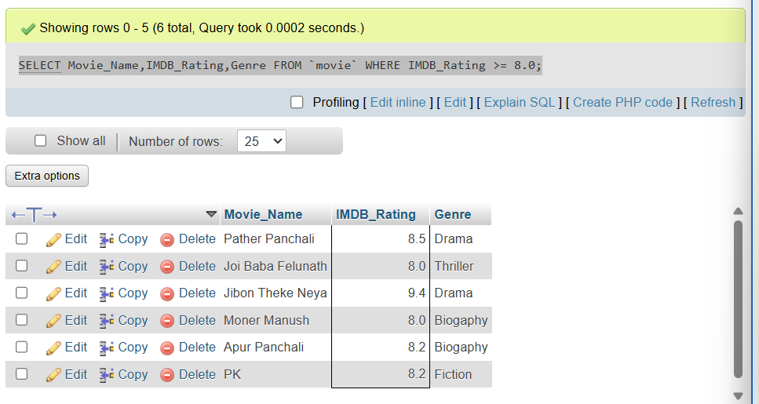
❖ Query 1.2: Find how many movies are there in each genre with an IMDB
rating less than or equal to 8.0.
SELECT Genre,COUNT(*) AS movie_count FROM movie WHERE IMDB_Rating <= 8.0 GROUP BY Genre;
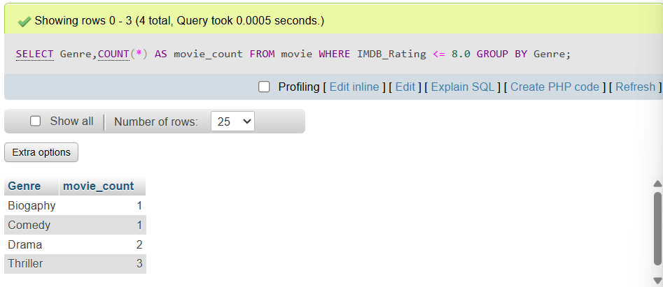

❖ Query 1.3: Find the name and the average IMDb rating of those genres
whose average IMDb rating is less than or equal to 8.0.
SELECT Genre,ROUND(AVG(IMDB_Rating),2) FROM movie GROUP BY Genre HAVING AVG(IMDB_Rating)<=8.0;
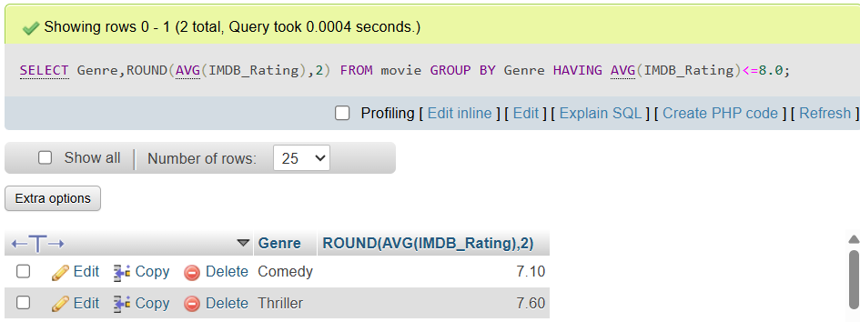
❖ Query 1.4: Find the name, number of films and number of awards of the
director who directed the most number of movies.
SELECT Director_Name,No_Of_Films,No_Of_Awards FROM director WHERE No_Of_Films=(SELECT MAX(No_Of_Films) FROM director);
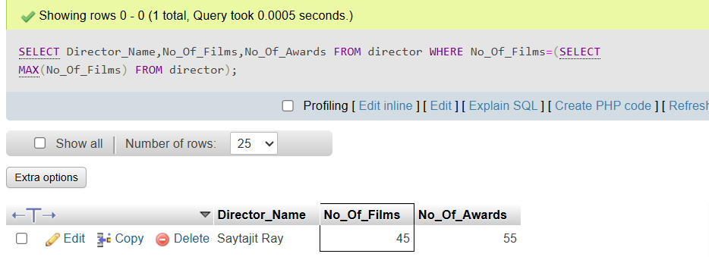

❖ Query 1.5: Find the name, current age, number of films and number of
awards of the youngest actor.
SELECT Actor_Name,YEAR(NOW())-Birth_Year AS CurrentAge,No_Of_Films,No_Of_Awards FROM actor WHERE Birth_Year=(SELECT MAX(Birth_Year) FROM actor);
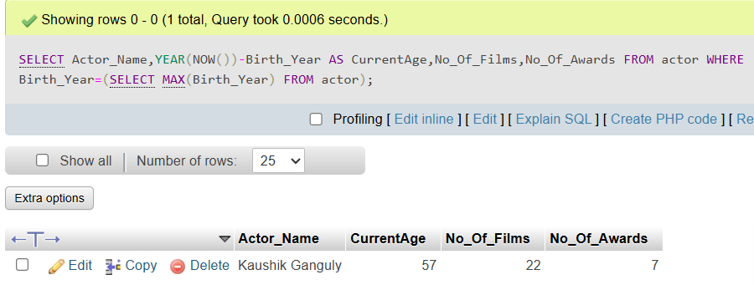
Level # 2
❖ Query 2.1: Find the name, number of films as a director, number of films as
an actor, number of awards as a director and number of awards as an actor of
all the directors. (If a director never acted in any film then number of films
and number of awards as an actor will be null)
SELECT director.Director_Name AS Name , director.No_Of_Films AS DirectorFilms, director.No_Of_Awards AS DirectorAwards, actor.No_Of_Films AS ActorFilms, actor.No_Of_Awards AS ActorAwards FROM director LEFT JOIN actor ON director.Person_ID=actor.Person_ID;
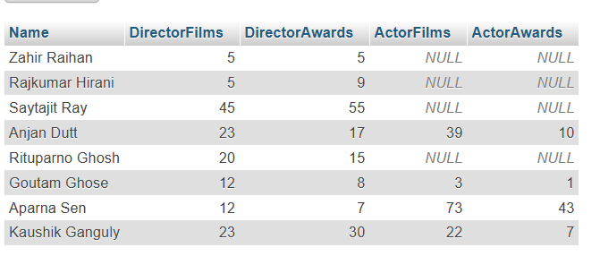

❖ Query 2.2: Find the name, number of films as a director, number of films as
an actor, number of awards as a director and number of awards as an actor of
all the actors and directors.
SELECT director.Director_Name AS Name , director.No_Of_Films AS DirectorFilms, director.No_Of_Awards AS DirectorAwards FROM director UNION SELECT actor.Actor_Name, actor.No_Of_Films AS ActorFilms, actor.No_Of_Awards AS ActorAwards FROM actor;
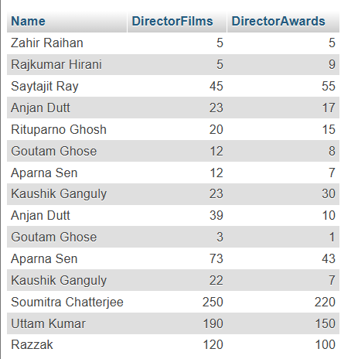
❖ Query 2.3: Find the name, number of films and number of awards of those
actors who never directed any film.
SELECT Actor_Name, No_Of_Films, No_Of_Awards FROM actor WHERE Actor_Name NOT IN ( SELECT director.Director_Name FROM director);


❖ Query 2.4: Find the name, IMDb rating and genre of those movies whose
IMDb Rating is above average.
SELECT Movie_Name,IMDB_Rating,Genre FROM movie WHERE IMDB_Rating > (SELECT AVG(IMDB_Rating) FROM movie);
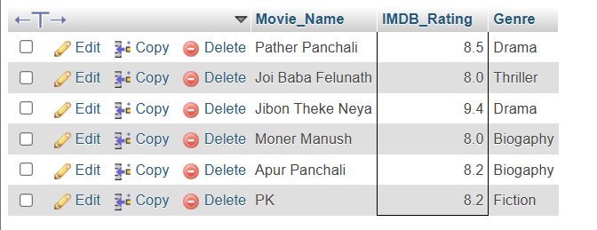
❖ Query 2.5: Among the average IMDb ratings of all the movie genres, find
the highest average IMDb rating.

